DESIGN AND ANALYSIS OF ALGORITHM-1
G VEDA KARTIK
CH.SC.U4CSE24212
- Write a program to find the sum of n natural using a user defined function
Code:
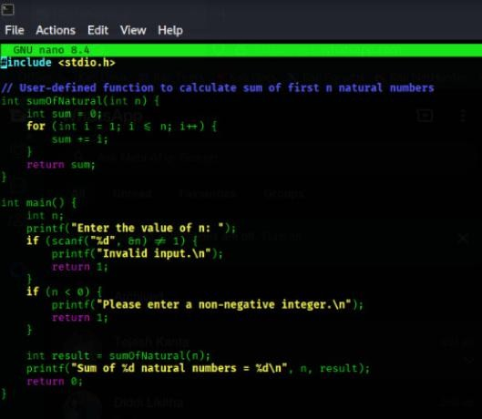
Output:
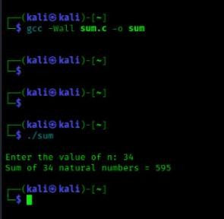
SPACE COMPLEXITY:-
- The space complexity of this program is O(1)
- REASON: constant space. Because the program uses a fixed number of variables, independent of the input size, its space usage does not grow.
- Write a program to find the sum of squares of n natural numbers
Code:
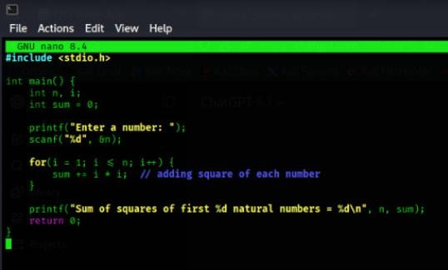
OUTPUT:
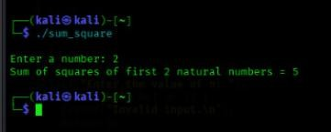
SPACE COMPLEXITY:-
- The space complexity of this program is O(1)

- REASON: constant space . Because there is no recursion, no arrays , no dynamic memory allocation , the amount of memory used does not depend on n.
- Write a program to find the sum of cubes of n natural the sum of cubes of n natural numbers
CODE:
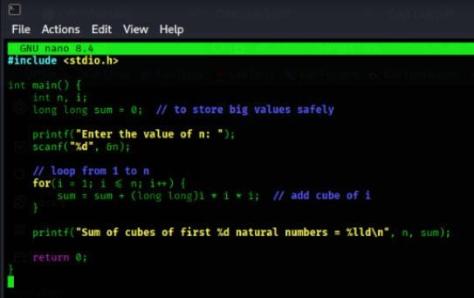
OUTPUT:
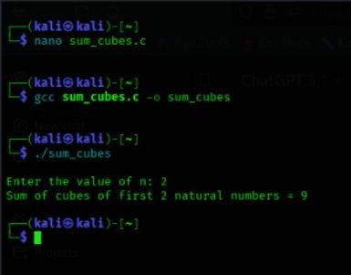
SPACE COMPLEXITY:
  - The space complexity of this program is O(1)
  - REASON: constant space . Because there is no recursion, no arrays , no dynamic memory allocation , the amount of memory used does not depend on n.
- Write a program to find the factorial of a given number using recursion
CODE:
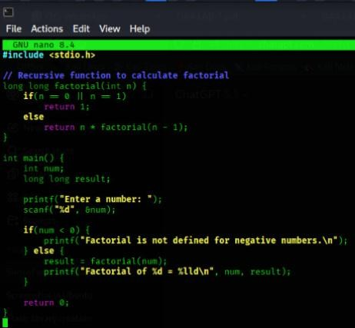
OUTPUT:
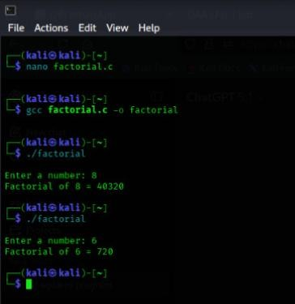
SPACE COMPLEXITY:
  - The function calls itself many times, and each call uses some memory.
  - More calls mean more memory is used, so memory increases with n.
  - That's why the space complexity is O(n).

- Write a program to transpose a 3x3 matrix
CODE:
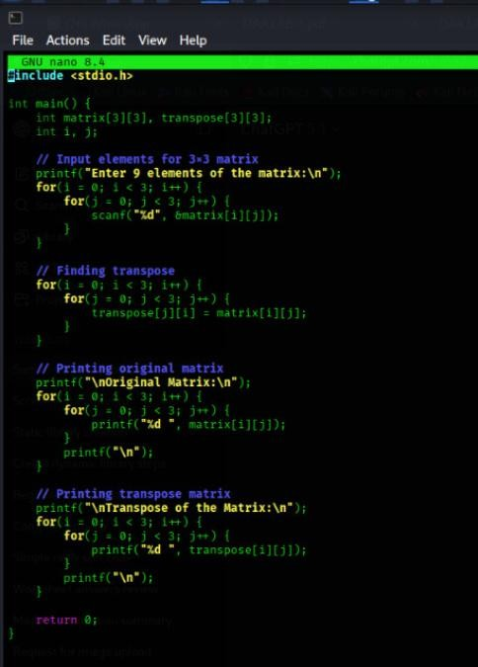
OUTPUT:
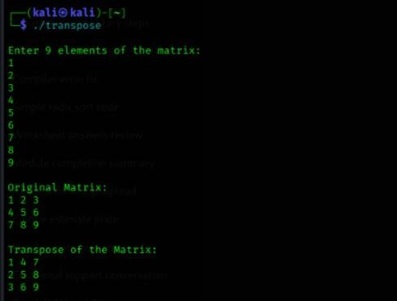
SPACE COMPLEXITY:
  - The program creates a 3×3 array, which is fixed in size and does not grow.

  - You only use a few extra variables for loops.
  - So the space complexity is O(1) 6. Write a program to find the Fibonacci series
- Write a program to find the Fibonacci series
CODE:
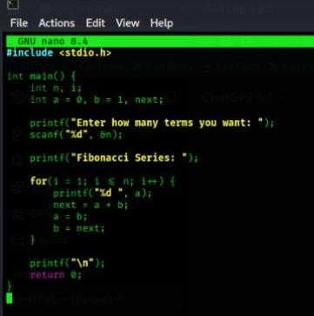
OUTPUT:
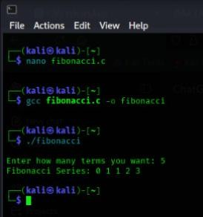
SPACE COMPLEXITY:
  - The program only uses a few variables (a, b, sum, temp) and these do not increase when n increases.
  - No extra memory grows with the loop.
  - So the space complexity is O(1).

